**Prayers September 2023**

A prayer, as we move into the season of Autumn:

*Heavenly Father, we thank you for the beauty of the Autumn season – the reds, yellows and oranges of the leaves that reflect our joy in your creation; the deep blue of the September sky that reflects the depth of your love for us; and the crisp, cool mornings that speak of change in our lives. We thank you for your ever-present step beside us. Give us peace and joy as we move into a new season in our lives, in our faith and in our love for you. In Jesus’ name we pray, Amen*

**As September begins**, we pray for our children beginning or returning to school and young people going to college or university. We pray for all the staff as they plan their education programmes and prepare to welcome students. We pray that they settle back well, stay safe and enjoy their time together learning and socialising. We especially remember those who are anxious and feel vulnerable.

We thank God for the opportunities of rest and recuperation, so we pray for those who are able to take holidays or have days out during September. We pray for safe, comfortable travels, with the experience of new sights, sounds and friendships.

We pray for Karen, our Diocesan President, Trustees, and others in leadership positions, as they plan services, events, and projects for the next year. Lord, may they be guided and inspired by your Holy Spirit, as they look ahead to the ongoing ministry to which they have been called.

On UN International Day of Peace **(September 21st),** we commit ourselves again to Peace and Reconciliation, with our partners in the Community of the Cross of Nails. Lord, help us to continue to promote peace through our MU activities and friendships.

We pray for Sixth Form students who will attend activities at Coventry Cathedral to explore themes of reconciliation **(19th – 21st).** May this be a time for listening, learning and questioning, as students come to a deeper understanding of peace and reconciliation in today’s world.

We pray for world leaders and governments, that they would use their authority and influence to work tirelessly to establish peace, so that families and communities can live in security and safety.

On **22nd September**, join with Mothers’ Union members around the world to worship, pray and learn about future developments for MU, at the Annual Gathering in York. We pray for Worldwide President Sheran, Central Chaplain Bishop Emma, and Archbishop of York Stephen Cottrell, as they lead the meeting and service. May it be a great time of fellowship for all.

Thank you, Lord for all our sisters and brothers engaging with families within their own communities around the world, to bring Christian love and care to others. In thankfulness, we pray that all the activities and events will bring glory to God. We pray especially for our overseas link partners in Akot, South Sudan; SW Tanganyika in Tanzania; Aba and Irele Ese-Odo in Nigeria; Cuttack in India.

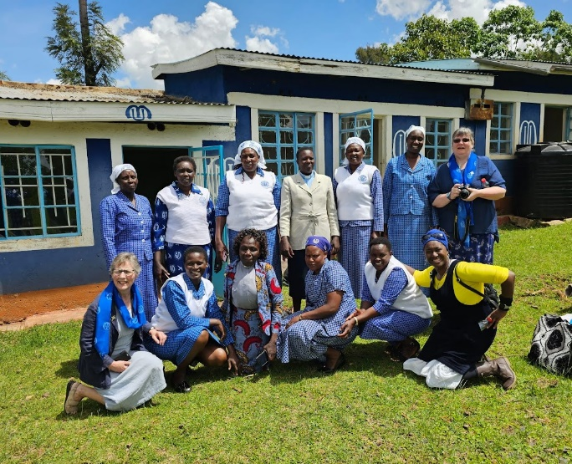We pray too for Mama Selline, Revd Emily and all Mothers’ Union members in Kapsabet, Kenya. We thank God for the friendships that have already been made and pray that this partnership will grow and develop through prayer.

All our prayers we ask in the name of the Lord Jesus. Amen